Think About What You Think
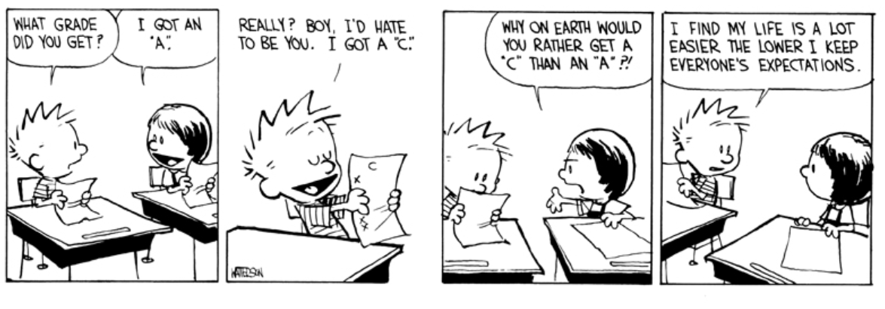
"In order for people to live their own lives and fulfill their destiny, they must differentiate themselves from destructive environmental influences." ~ Lisa Firestone

Food for Thought...
The successfully differentiated self can have significant influence on the entire family system, catapulting it forward toward higher levels of functioning.
Think about this statement as you watch the video and complete the rest of the assignment. Make sure you follow "the instructions."

The Prompt
Differentiation is the ability to balance autonomy and attachment so it is not an "either/or" all or nothing proposition. The differentiated self, then, becomes the ability to be connected to one's thoughts, values, and feelings, while also remaining close to someone, i.e. a parent or sibling. The more differentiated the self is, the closer the two forces of autonomy and attachment become in a family system.

The Discussion Instructions
- Watch the "Bowen Family Systems Theory" video here.
- Using the video, your textbook, and other resources, discuss the impact of triangles on the family system.
- What did you discover about your family's influence on you and your differentiated self?

Note:

  - You must submit a post BEFORE you can see your classmates posts.
  - Ideally, your response to your classmates should consist of a complete thought that contributes to the dialogue and furthers the discussion.
  - There are no right or wrong responses, so share your knowledge, insights and thoughts freely,
  - but please be respectful to one another as you explore and discuss your ideas.
  - See the discussion rubric (in rubric link on the navigation bar) for grading criteria.
  - Discussion is due on Sunday February 28, 2021 at 11:59pm.
Click the Next ▶ button at the bottom right corner

